Project 1

4-Card GOLF: The Card Game

Course

CIS-05

Date

5 November 2018

Author

Jrrobert Jabonillo

**Introduction**

Welcome to the game of 4-card golf!

This is a card game that is played with 2 or 4 players. Each player receives four cards at random. Each card given is face down; therefore the player is unknown to the value of the card. Each player is given an opportunity to look at two cards in their given hand. The rules of the game are that there are a total of 8 turns within a game. A turn is completed once a full rotation is down around back to player one. The game may also end if a player decides to knock, if the player knocks the rotation must be completed and all players must total the amount they have based on the cards in their hand. Numeral card from 3 to 10 scores face value. An Ace card is 1 point. Jack and Queen Cards scores 10 points. A king card scores 0 points and if there is a pair the player receives 0 points.

The goal of the game is to have the least amount of points at the end.

**Summary**

Project Line: 6685

Number of variables: 31

Within the project includes must of what has been learned through Chapter 1- 5 of Gaddis 9th Edition. The project took about five days to finish, as some parts of the project were not working and I had to first create a write up of how the project would perform. Though the project is simple and the game is contains not that many rules in regards to the gameplay, I had worked through most of the bugs, but the project may still contain errors in some areas. An area I had difficulty with, was being able to create a means of do while, for the gameplay portion until total turns was 8. As the increment would not count properly up, therefore I decided to scrap the idea and create a for loop as a replacement. Within this write I had given examples of inputs and outputs, along with a flowchart for the basis of the project.

**Version 1**

Version 1 of the project was to create the portion of the project where the players are given random cards with the values. And to have the portion where the players can decide the two cards they want to view within their hand.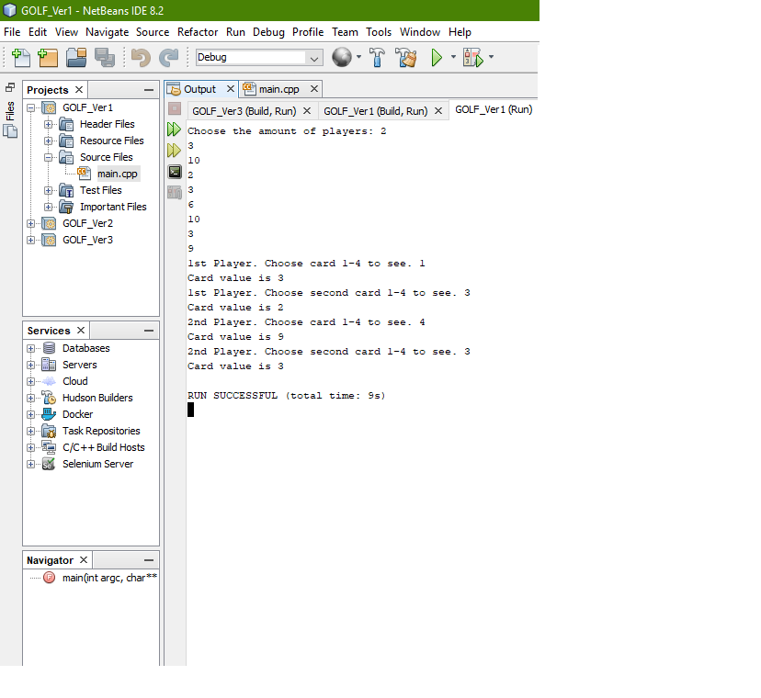

**Version 2**

Within version 2 the goal was to create the core gameplay of the card game. To create the means of having the player the ability to swap their cards and the ability to draw from deck. Another portion of version 2 was to create the limit of reaching 8 turns or stopping the game once a player knocks.

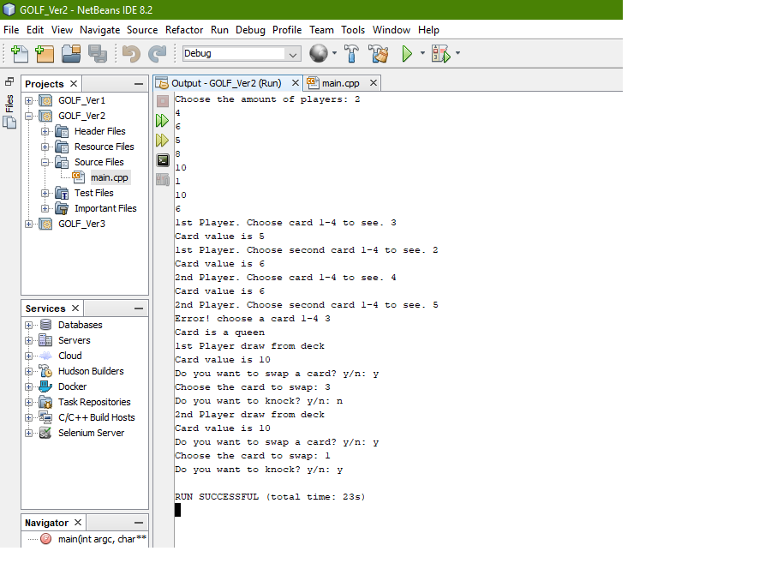

**Version 3**

With much of the core gameplay finished, the final steps would be to include an introduction within the program and to remove the outputs that were not required in the game. And to remove bugs that may have been found when attempting to play the game with three or four players. Also, version 3 would include the results of the game and output the result into a separate file that is within the folder of the project.

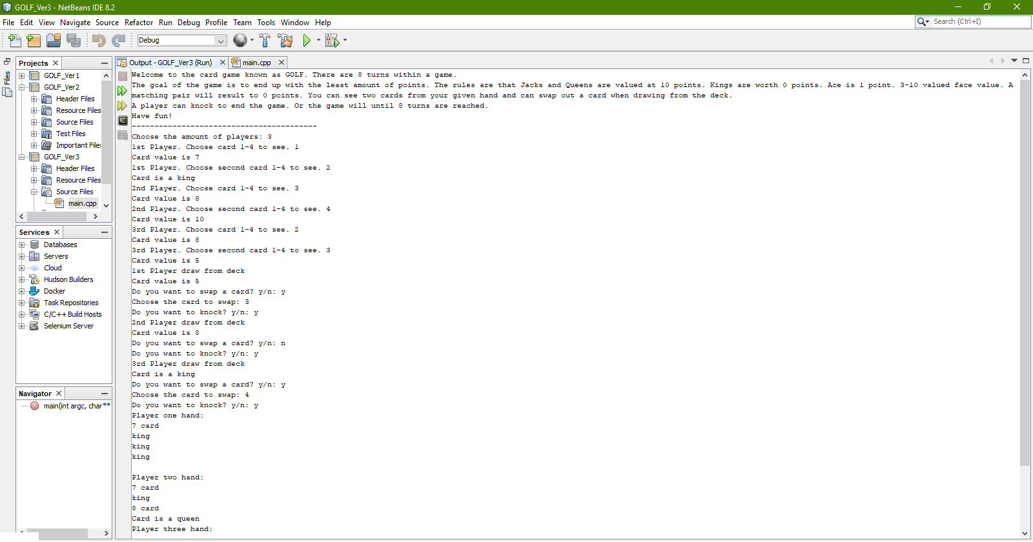

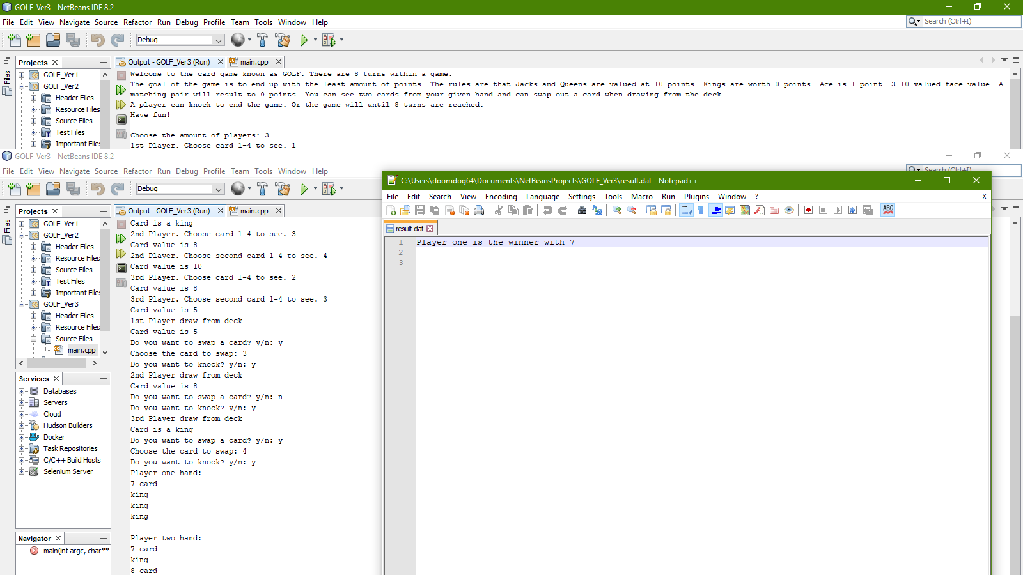

Within the project I had attempted to apply every topic into the project, but some such as float did not find a place into the project. As I did not know where float could have been used within the project, but besides that the project went fine and it could be greatly shorten down if it has used functions and arrays.

**Pseudocode:**

jacks and queens = 10

ace, 2-10 = face value

king = 0

hold = number that is drawn from deck

player gets 4 cards

Each ace counts 1 point.

Each 2 counts minus 2 points.

Each numeral card from 3 to 10 scores face value.

Each jack or queen scores 10 points.

Each king scores zero points.

A pair of equal cards in the same column scores zero points for the column (even if the equal cards are 2s).

randomly chooses card value for both players

enters while loop until nine deals (deals == 9) deals++ or until knock (if statement) player1 knocks == player2 knock

ask first player to see their card.

asks the user which card to see. (switch statement)

ask second player to see their card.

ask user which card to see (switch statement)

ask first player to swap card (if statement) if user does not swap deck

user draws card from deck. deck - 1 (random number)

card is displayed to user

user enters which card to swap (switch statment)

ask user to swap card. card value enters for loop(for loop). And this for loop is in a while loop(whileloop) that stops when it is done

asks user if they want to knock (if statement) deals = 8

ask second player to swap card (if statement)

user draws card from deck. deck - 1

user enters which card to swap (switch statement)

ask user to swap card. card value enters for loop. And this for loop is in a while loop that stops when it is done

asks user if they want to knock (if statement) deals = 8

at the end saves results to a file.